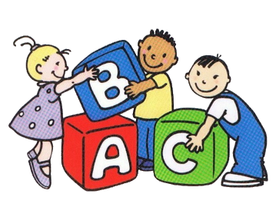

Parkview Village
Day care List
- Above and beyond …………………………………..(336) 887-4521
- A child’s World………………………………………..(336) 889-2211
- Childcare Network……………………………………(336) 854-5710
- Faith & Love……………………………………………(336) 887-4521
- High Point church…………………………………….(336) 848-3486
- It Starts here Daycare……………………………….(336) 869-6971
- Kids Academy…………………………………………(336) 885-1002
- Mary’s Christian Learning Center…………………(336) 869-6252 & 989-1613
- Mema Kings Kids……………………………………..(336) 4713994
- Little Ones World Academy…………………………(336) 889-9050
- Oak Hollow……………………………………………..(336) 883-9110
- Triad Child Development…………………………….(336) 889-0409
- Morehead……………………………………………….(336) 883-3506
- YMCA Carl Chavis…………………………………….(336) 434-5440
- YMCA Hartley………………………………………….(336) 869-0151
- YWCA Gaterbarawood……………………………………..(336) 882-4126
- Community connections…………………………….(336) 883-0650

